Excel Macros

Disclaimer
These macros were written specifically for Xcalibur data for GC-MS analysis after using a script (munge) to produce a single data sheet for analysis.

As such, there may be cases where your data matrix does not match, and hence the macros will not behave as expected. If this is the case, you will need to edit the macro to suit your needs (or have someone do it for you).

If sheets are not named as per the template or as defined below, the macros may not function.

There is no undo function once you have run a macro! If you’re new to all this, and/or testing these, please back up your data until you’re comfortable with how it works.

Installing the Macros
To have these macros available for your use, open Excel and click
Tools --> Macros --> Visual Basic Editor

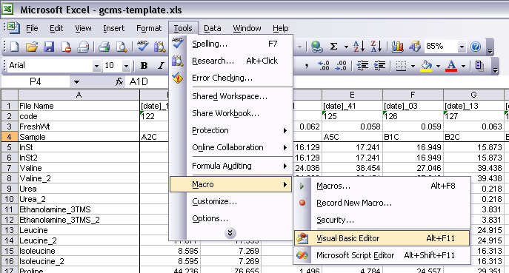

for Excel 2003 or press Alt+F11 for Excel 2007 which will open the VBE window. In the left hand top panel, there will be 2 projects (generally, depending on what you have open), click on the one that says 'VBAProject (PERSONAL.XLS)'.

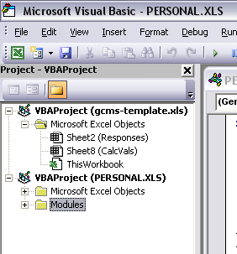
If you do not have this, you will need to create it. This is done by going back to your Excel window, and clicking
Tools --> Macro --> Record New Macro...
or for Excel 2007 by clicking
View --> Macros --> Record Macro...
Make sure you change ‘Store macro in:’ to Personal Macro Workbook. Record something and press stop, then open the Visual Basic Editor.

Take note of whether the VBAProject is called PERSONAL.XLS or
PERSONAL.XLSB

Click
File --> Import File...
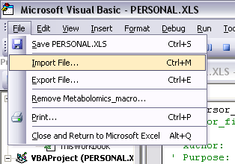
If your PERSONAL file is .XLS, select MA_macros.bas. If it is .XLSB select MA_macros_07.bas.

This will put in into a module. To check that they are all there, click
Tools --> Macro --> Macros...

or for Excel 2007, click
View --> Macros --> View Macros
and verify you have the new macros in that list.

Basic Methodology

Step 1

Generate a response matrix
This will be dependent on your platform, data output, processing, etc. Once it is in a format that matches the example in gcms-template.xls (the Responses tab), you can then use the macros as described below.

Step 2
Determine which sample will be the reference sample. If there is more than one, you will need to be very careful with cell references, and edit them later.

Ensure that the reference samples (or the primary one if you have more than one) are the first samples in the response matrix. Click
Tools --> Macro --> Macros... or
View --> Macros --> View Macros
and select resp2calcvals. Click Run.

If this produces “Compile error: User-defined type not defined”, go to the Visual Basic Editor and click Tools-->Reference... and check the box “Microsoft Scripting Runtime”.

If you have more than one reference sample, you will need to edit the t-Test cell references for those samples (change the formula to “1” so that it is not marked as significant) as well as those samples that use that sample as the reference (i.e. change it from the first group’s cells to the new reference group’s cells). For example:
Reference group 2 (P5:T5):
Old: =TTEST(Responses!$P5:$T5,Responses!$B5:$E5,2,2)
New: 1
Samples for reference group 2 (U5:Y5):
Old: =TTEST(Responses!$U5:$Y5,Responses!$B5:$E5,2,2)
New: =TTEST(Responses!$U5:$Y5,Responses!$P5:$T5,2,2)

Once you are happy with how it all looks, we can then move on.

Step 3

Highlighting significant values
Click
Tools --> Macro --> Macros... or
View --> Macros --> View Macros
and select emBoldT_pretty (if you have duplicate metabolites; if you have single entries, use emBoldT_pretty_2). Click Run. Enter the number of sample groups you have (collections of columns; for the template data this would be 6).

Values that are highlighted in green (with bold and italic formatting for good measure) have a t-Test value
P < 0.05 / (number of metabolites)
while those with cyan (and bold) highlight are between this P value and 0.05 (i.e. below 0.05, but not below the Bonferroni-corrected P value)

Step 4

Creating the Overview sheet
Check that there are no sheets called Overview that you do not wish to overwrite. Click
Tools --> Macro --> Macros... or
View --> Macros --> View Macros
and select calc2oview. Click Run. A new sheet will be generated with only the x-fold and standard error of the mean (sem) data.

Step 5

Creating the Folds sheet
Once again, check that there isn’t already a sheet called Folds, otherwise it will be overwritten, then click
Tools --> Macro --> Macros... or
View --> Macros --> View Macros
and select oview2folds to create the sheet.

Step 6

Showing fold changes by colour
Two macros will change the colour of values in the Overview (fold_colour_ov) and Folds (fold_colour_fl) sheets based on the value of the fold change:

> 6-fold
6 > x-fold > 4
6 > x-fold > 4
-2 < x-fold < 2
-4 < x-fold < -2
-6 < x-fold < 4
< -6-fold

After running this macro, you will notice that the original cyan and green colours have been lost, however the bold and italic are still present, allowing you to see which changes were significant and which were not.

fold_colour_ov will convert the values that are less than one to a negative fold value (i.e. 0.25 becomes -4.00–fold). fold_colour_fl does not do this, but there is a macro called neg_folds_fl that will convert between the two formats if it’s not the correct one (see below).

Step 7

Sorting compounds
The macro cpd_sort will, as you may imagine, sort out the compounds based on class.

The way this sorts compounds is by having a lists of compound names for each class (i.e. all amino acids in one list, all sugars in another). If some of your compounds end up in ‘Other compounds’, it’s because they’re not in the lists. Adding the compound name to the appropriate list will fix this (see the comments in the code).

Removing derivatisation tags
The tms_trim macro will remove all the _nTMS, _nTBS and _MXn tags for cleaner output.

Bonus Macros

Checking your data matrix
A function called minmax_all will highlight the highest and lowest values in a row with red and blue borders respectively. Useful for GC response data - if a peak has been mis-assigned, the value will often be either much higher or lower than expected.

Removing duplicates
Part of the calc2oview macro is a step that removes duplicate metabolites (those entries with _2 on them). If you wish to do this at a different step (for example at the Responses tab), click
Tools --> Macro --> Macros... or
View --> Macros --> View Macros
and select dupRem. The calc2oview macro runs this macro as part of itself.

Converting negative folds to positives
neg_folds_ov and neg_folds_fl will change all the values that are below 1 to their negative inverse value. For example, a fold change of 0.25 versus the control is actually a 4-fold decrease, and will be shown as -4.00 after running this macro. fold_colour_ov uses this macro; as such, if you’ve run either of those more than once, it’s often a good idea to use the corresponding neg_folds one to get them back to normal before trying it again.

Resetting the cursor
Many of these macros have two lines at the start that say ‘don’t show what’s happening on the screen’ and ‘change the cursor to the hourglass’. When one of these macros break, they leave your cursor as the hourglass which can be annoying. There’s a macro called cursor_fix which will set it back to the normal one.

Importing multiple .csv files to one Excel spreadsheet
import_multi_csv will ask you to select .csv files to bring into a single Excel file. If the file names are too long, it will truncate them, and if the truncated file name matches another sheet’s name, it will append _2, _3 etc after it.

Support
Unfortunately, most people who write code loathe and detest VBA. Don’t expect your local IT staff to help you too much with it! That being said, it’s not that difficult to follow (I taught myself in a year or so to get to this level), and there is plenty of help via google. There is some basic information on usage and purpose in the macros themselves, as well as comments regarding what some of the specific sections of code do if you need to edit them.
Tools --> Macro --> Visual Basic Editor
will get you to the macro code itself.

If all attempts to fix your problem fail, please contact MA staff at University of Melbourne (Botany) on +61 3 8344 3318 as they have had a lot of practice with running these macros.

For example hold control and press B, I, Home. It really doesn’t matter what you do, you just need to create the file.
Okay, not just that. There are other macros which will remove this colouring, and provide other information by colour. Doing it this way enables richer data analysis. See Showing fold changes by colour.
Benjamini, Y & Hochberg, Y (1995) Controlling the False Discovery Rate: A Practical and Powerful Approach to Multiple Testing. Journal of the Royal Statistical Society. Series B (Methodological). 57(1):289-300.
Please ensure that the column headings are the same. If they are not, they will be deleted!

